BrioCare: Parent Validation for AI-Assisted Pediatric Group Therapy

Executive Summary
Study Goals. Validate whether parents recognize engagement problems in current group therapy, accept an AI co-facilitator alongside a licensed therapist, and would try a $50–100/session telehealth program.

Key Findings.
- The engagement gap is real and universally recognized: every parent flagged that quieter kids get overshadowed, freeze, or zone out in groups, and one mother described her daughter going silent and "staring off" in a prior group session.
- Comfort with the concept is high, but intent to try is softer: 8 of 9 parents are at least somewhat comfortable with an AI-assisted session, yet only 5 of 9 would try it at $50–100 per session. Cost and trust gate adoption.
- The acceptable AI scope is narrow but valuable: parents endorse AI for turn-taking, prompts, and structure; they push back hard on AI doing anything resembling therapy, reading emotions, or socially engaging the child.
- The value proposition that resonates is inclusivity, not cost or telehealth. Equal participation and individualized therapist attention are the most universally critical factors, which is what BrioCare's AI co-facilitator is designed to deliver.

Who We Talked To. 9 U.S. parents of children ages 6–12, all of whom have used therapy/counseling in the past 12 months. All 8 reported shyness or social anxiety in their child, and 7 reported low self-confidence. Squarely BrioCare's bullseye persona.

Parents see the engagement problem clearly, and it's vivid
Every parent in the study recognized that quieter children risk being overlooked in group settings (8 of 9). This isn't an abstract worry. It shows up in concrete, visceral terms.

One mother's child had tried group therapy and shut down completely: "The therapist noticed that she wasn't able to engage and that she got lost in the group and just stared off." Even with the therapist's encouragement, the child "sat quietly and just froze." A former-teacher mother described the exact mechanic BrioCare aims to solve: "she would definitely lack focus and get sort of overshadowed by more outgoing people."> "She wasn't able to engage and got lost in the group and just stared off."

Parents already know the fix is structural, not motivational. They describe smaller groups, intentional turn-taking, and a facilitator who keeps tabs on who has and hasn't spoken, which is essentially the BrioCare co-facilitator's job description. The first leg of the validation holds firmly.

The system, not the therapy, is broken
Before parents even meet a therapist, the access journey has already worn them down. The top frustration is finding a therapist their child clicks with (7 of 9), compounded by wait times (2), insurance dead-ends, and therapist turnover.
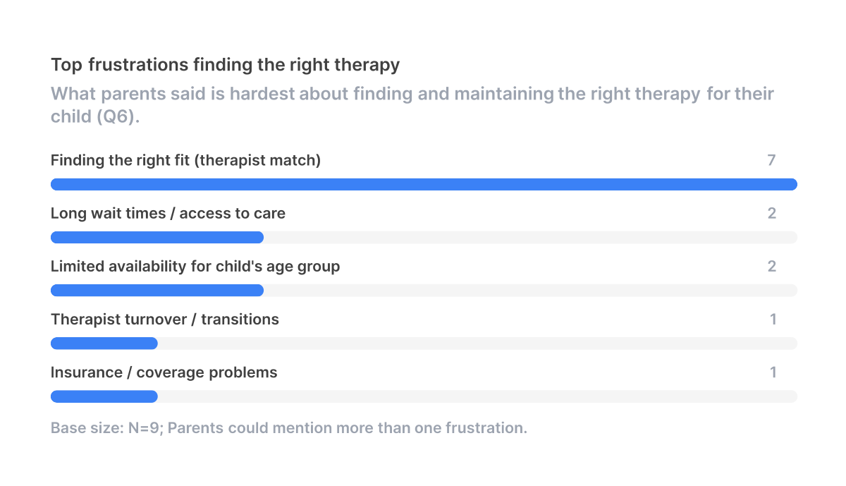
One parent went through three clinics before finding the right fit . Another waited nearly a year because insurance kept steering her to telehealth services that didn't cover her daughter's age . A third needed a crisis to unlock care: "We had called emergency services when she mentioned that she wanted to die... we knew immediate action had to be taken." A fourth is on her third therapist in under a year because the one her daughter loved is leaving .

Implication for BrioCare: the acquisition pitch shouldn't lead with AI. It should lead with access, short waitlists, consistent clinicians, and a clear path to a peer group that matches the child's issue.

Inclusive participation beats every other program attribute
When asked what matters in a group program, the unanimous top vote was that every child gets equal opportunity to participate. Every parent rated it Critical or Very Important. A three-way tie sits one step behind: individualized therapist attention, engaging sessions, and shared progress with parents.
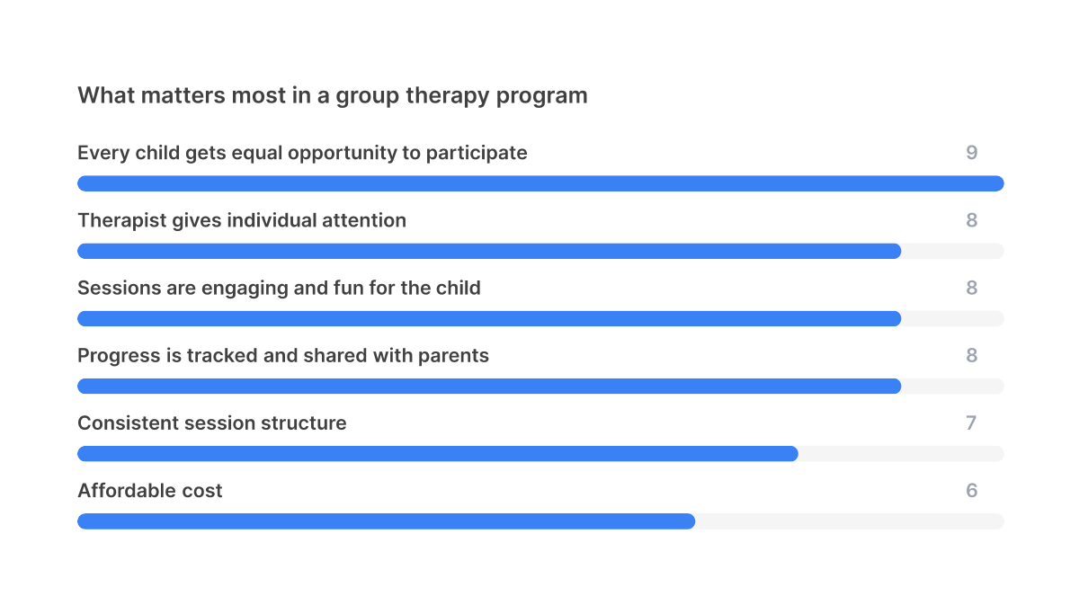
Two things stand out. First, the top-rated factors map almost one-to-one onto BrioCare's value proposition (equal participation, therapist attention, engagement). Second, affordable cost was the least critical factor: no parent rated it Critical. Parents will pay for quality, not the other way around.

The concept lands, but "comfortable" doesn't mean "will buy"
Parents comfortable with AI co-facilitator: 89% of parents are at least somewhat comfortable with an AI-assisted, therapist-led session
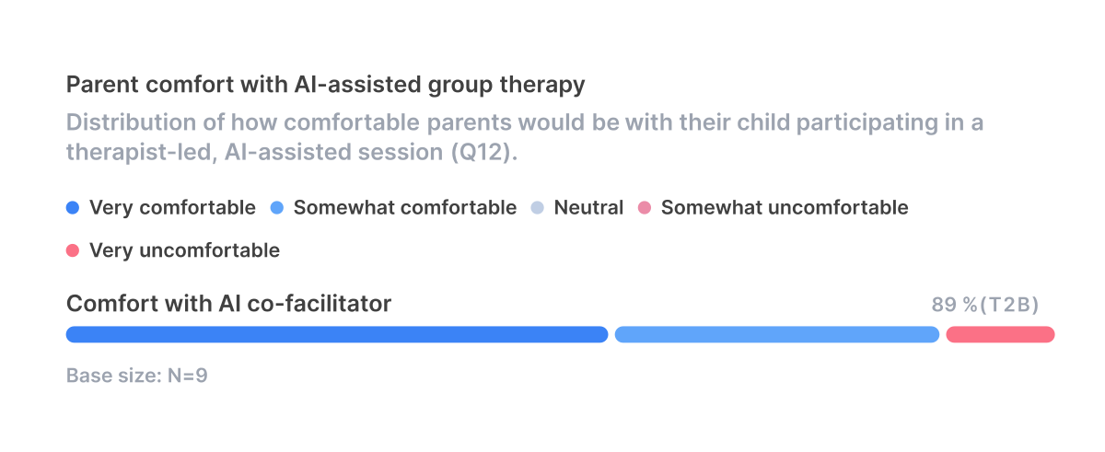
Four of 9 parents are at least somewhat comfortable with the AI-assisted session as described, including 5 who picked "Very comfortable." But intent to try at $50–100 per session is softer:
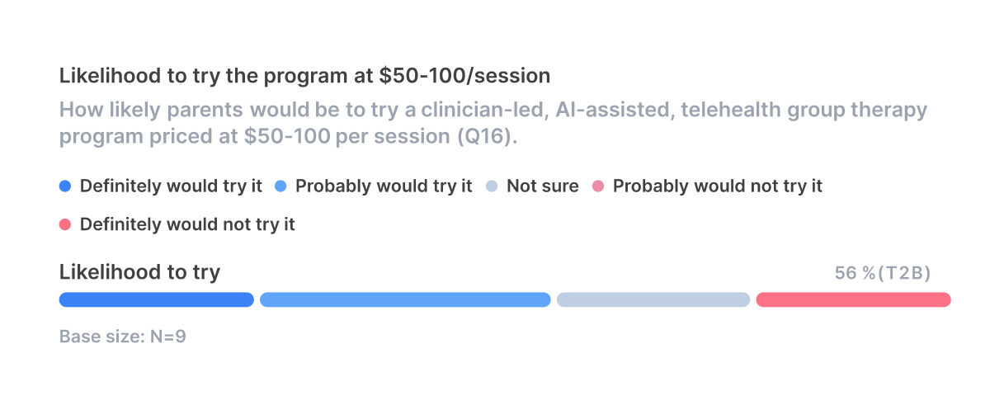
Only 5 would probably or definitely try the program. The gap between comfortable and would try is driven almost entirely by cost-relative-to-insurance. One parent who picked "Somewhat comfortable" still said "Definitely would not" because "my child's copay for her therapy sessions is much lower than that... it just wouldn't make sense." A second hard-no parent doesn't trust AI in any medical context at all .

Translation: the concept is not the blocker. Out-of-pocket pricing against an insured copay is.

Parents draw a precise line: AI runs the room, not the therapy
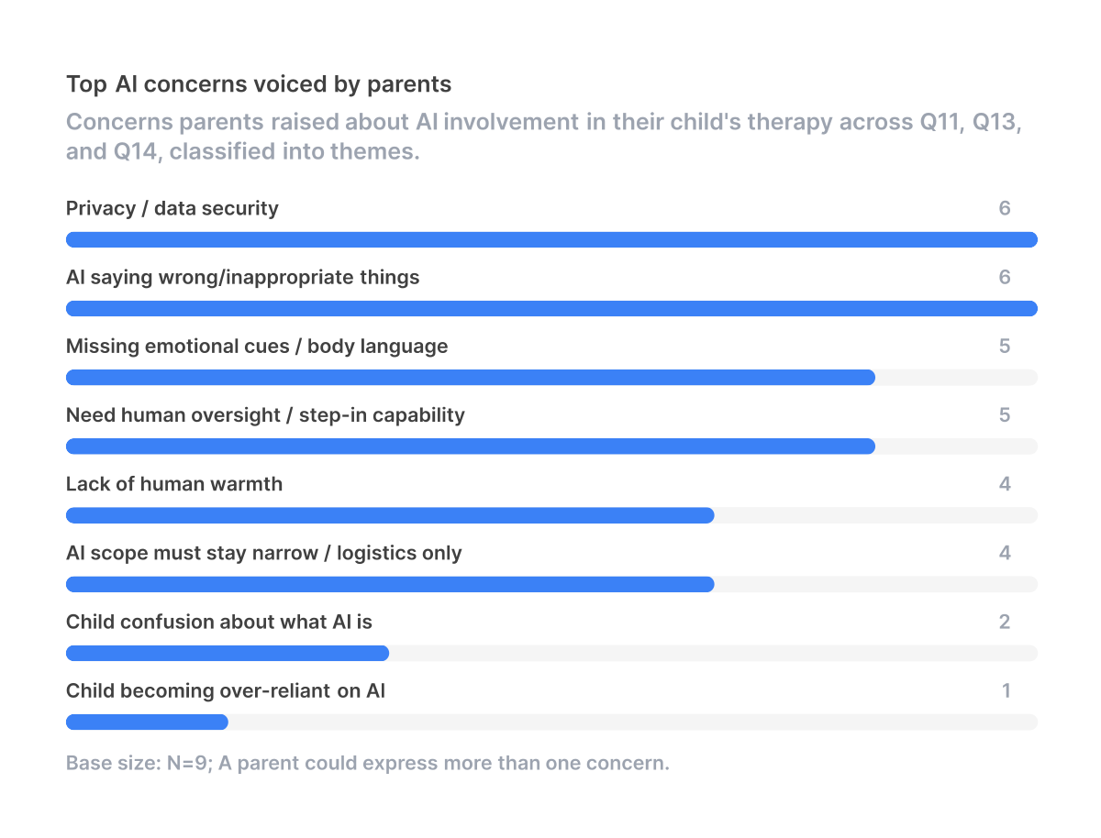
Parents articulate a consistent mental model of acceptable AI scope. 5 of 9 insist the therapist must remain in full control with the ability to step in at any time. 4 explicitly want the AI confined to logistics: timers, turn-taking, structured prompts.

"I'm pretty comfortable with the idea of AI doing tracking components... I'm less comfortable with the idea of the kids interacting with AI in any way."

Within that envelope, parents see real value. One mom flipped from initial skepticism to enthusiasm the moment the interviewer clarified the therapist remains the social anchor: "that sounds like a great setup because then the therapist can focus on... just the kids. She doesn't have to worry about timing or like, you know, just the little things."

Four distinct anxieties keep parents on guard:

- Privacy and data security (6 of 9): worry about breach and where session data lives.
- AI saying the wrong thing (6 of 9): bad advice, misrepresentation, taking therapy "the wrong direction."
- Missing emotional cues (5 of 9): facial expressions and body language a human would catch.
- Loss of human warmth (4 of 9): "an actual person is more warm and inviting, and I think... easier to talk to."

One parent surfaced a more subtle product risk: shy kids becoming over-reliant on the AI as an easier alternative to peer interaction. "it could be very easy to sort of depend on that interaction, because it's easier than having to interact with people... That would certainly be a step backwards." This is the strongest argument for keeping the AI invisible to the child.

The bullseye user wants more AI, not less
The most enthusiastic parent, whose daughter had previously frozen in group therapy, saw the AI as a communication accommodation rather than a session manager. She wanted the AI to be a private channel her daughter could use to participate without speaking aloud:

"Having an AI she could text to or select options as to how she feels, or an AI that could communicate to the therapist for her what she has said."

This is a meaningful product signal: for the kids BrioCare is trying to reach, the AI's most valuable function may be giving non-verbal kids a low-stakes input mode (text, emoji, multiple choice), not orchestrating turn-taking. The idea came from a single parent and should be treated as a hypothesis to test rather than a confirmed need, but it is the single most emotionally resonant product idea any parent surfaced.

Telehealth is a non-issue and may even be an asset
The screen, surprisingly, helps. Even the parent of an autistic child who is otherwise a hard no on the AI piece said video would be fine and could make it easier for her shy daughter to participate: "that might make it easier for her because she can also ignore the other kids in the room if she needs to." Another parent noted her daughter is already used to Discord-style group calls and might feel more at home .

One nuance: combining telehealth with a child-facing AI raised a boundary-blurring worry for one parent. Young kids might have trouble distinguishing the AI from the therapist when both are on a screen . That risk vanishes if the AI is non-anthropomorphic and operates in the background.

Recommendations
Build the MVP, with three product guardrails.

- Position the AI as session infrastructure, not a participant. Marketing copy and onboarding should describe the AI doing turn-taking, structure, and prompts, never "talking to your child." 4 of 9 parents flinched at AI warmth and 5 of 9 demanded therapist control. In at least one case (R111), the parent visibly relaxed once that distinction was clarified mid-interview, suggesting careful framing of scope is a meaningful unlock.
- Lead the value prop with inclusivity and access, not cost. Equal participation is the universally critical attribute, and the screening data shows 8 of 9 kids in this sample fit the social-anxiety bullseye. Price will not win the comparison against an insured copay; clinician quality and a peer cohort of similar kids will.
- Solve insurance and waitlist friction before scaling. The 7 of 9 parents struggling with fit and 2 blocked by waitlists telegraph where churn will come from. In-network status, fast intake, and clinician continuity matter more than any feature on the AI roadmap.

Expand the product concept in one direction: give children a non-voice way to participate (text, emoji, structured options that the AI relays to the therapist). This was the single most emotionally resonant idea any parent raised, and it directly addresses the freeze response that breaks group therapy for shy kids.

De-prioritize: anything that has the AI reading emotions, replying conversationally to the child, or operating without a visible human in the loop. Those features will reactivate the exact concerns that turned the two rejecters into hard nos.

